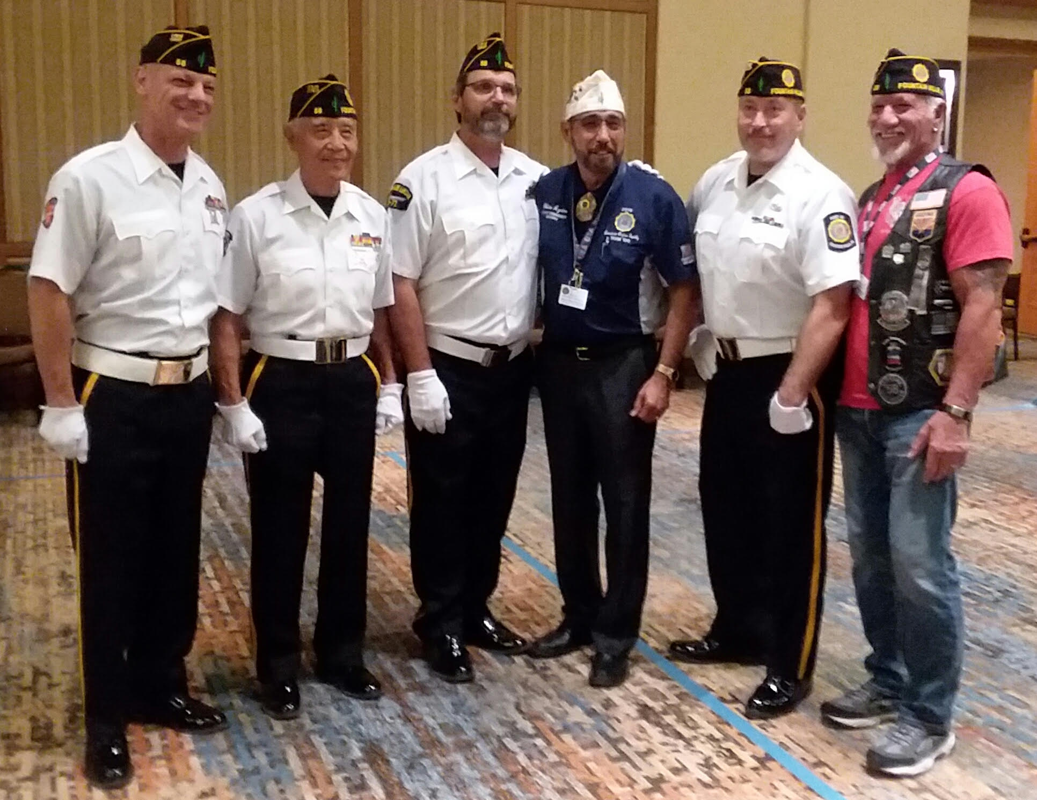
On August 22 thru August 26, 2019 Fountain Hills Post 58 Color Guard will be traveling to the 101st American Legion Convention in Indianapolis, IND. to defend its 2018 Military Class National Championship. The Color Guard will be competing in two events, the Posting and Retrieving Class and the Military Class.
It is an honor that Post 58 will be representing the AZ Dept of American Legion and all AZ American Legion Post. Post 58 is the 2018 & 2019 AZ American Legion State Champions.
If any Post or Legionnaire wishes to donate to help cover travel expenses, you can mail your donation to Fountain Hills American Legion Post 58, 16837 E. Parkview Ave, Fountain Hills, AZ 85268 Attention: Color Guard.
We thank everyone for your support. Kevin Wood, Phil Yin, Gerry Jacobus, Tait Elkie, Andy MacDonald, Bob Putnam, Bob Schmitz, Harland Peele, Tom Pagliuco
Members in Bold will be making the trip.

