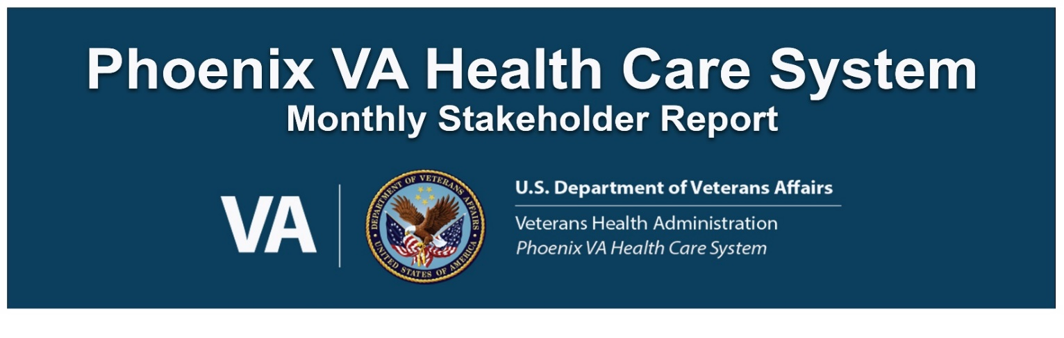
December 2022

COMMUNITY INVOLVEMENT
The Phoenix VA Health Care System continues putting forth a diligent effort to support all Veteran groups throughout our community and rural areas across the state of Arizona. The list below were events the PVAHCS attended and/or provided support and resources.

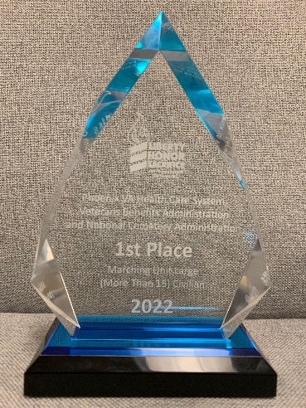
- December 3 - Michael Welsh attended the Veterans Day Parade Awards Ceremony where the Phoenix VA Health Care System was awarded 1st Place Large Civilian Marching Unit for 2022.
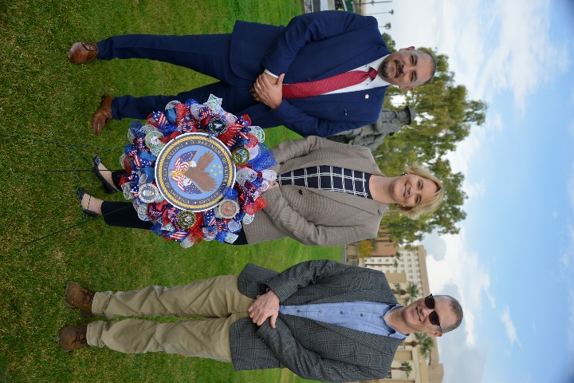
- December 7 - Dr. Leslie Lockridge, Acting Deputy Medical Center Director laid the Phoenix VA Health Care System Wreath during the Pearl Harbor Remembrance Ceremony.
- December 12 - The Phoenix VA Health Care System was selected as one of the VHA healthcare systems to hold a large-scale screening event for the new PACT Act. The PACT Act Telephonic Townhall was completed on December 12. Over 140K local Veterans were reached out to and around 33K attended the call.
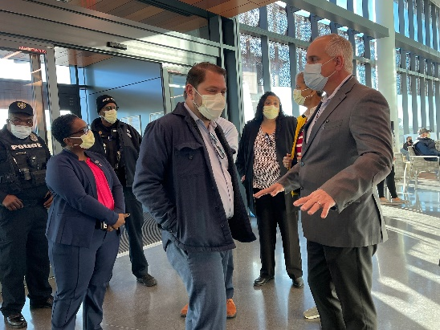
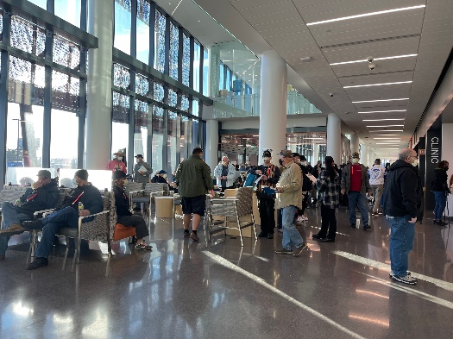
- December 17 - The Phoenix VA Health Care System partnered with the Phoenix VA Regional Office and Arizona Department for our first ever PACT Act Screening Event. The event was held on Saturday, December 17 at the new Phoenix 32nd Street VA Clinic to inform Veterans, their families, caregivers, and survivors about the PACT Act and encourage them to apply for the toxic exposure-related health care and benefits they have earned. This event included special guests, Phoenix VA Health Care System Interim Medical Center Director Michael Welsh, Phoenix VA Regional Office Director Chris Norton, Arizona Department of Veterans Services Director Wanda Wright, VISN 22 Desert Network Healthcare Network Director Michael Fisher, Under Secretary of Benefits Senior Advisor Julia Gusse, Office of the Secretary Veteran Affairs Tahmika Jackson, and Congressman Ruben Gallego. Local VA was on site to help Veterans apply for benefits, complete toxic exposure screenings, and enroll in VA health care.
- December 21 – The Phoenix VA Health Care System hosted the Annual Jewish War Veterans Menorah Lighting Ceremony at the Carl T. Hayden VA Medical Center. Our new Medical Center Director, Mr. Bryan Matthews, took part in the ceremony and lit the shamash. The Chief of Staff from Congressman Greg Stanton also took part in the ceremony.
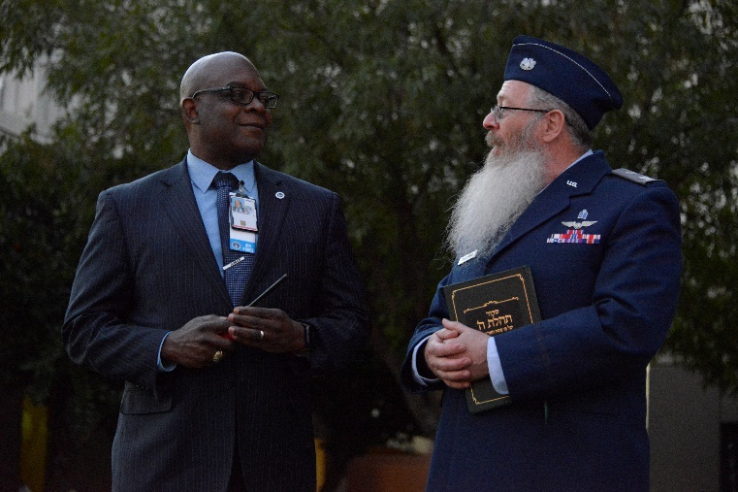
- Executive Leadership Team is always busy making their rounds to check up on various departments, clinics, programs, staff, and Veteran patients. They even make sure to visit all our community-based outpatients’ clinics even the ones located outside the Phoenix Metropolitan area. We have clinics located in Show Low, Payson and Globe where they also met with concerned Veterans.
- Phoenix VA Health Care System has been partnering with local tribal leadership and Indian Health Services to ensure our Native American and often rural Veterans receive care and services.

stem and
AROUND THE FACILITY
- December 6 - Another successful Veggies for Veterans was held on December 6 at the Carl T. Hayden VA Medical Center. 700 bags of fresh fruit and vegetables given out along with 500 pairs of socks!
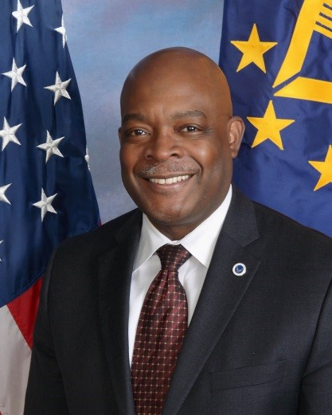
- December 18 - Bryan Matthews started his new role as the Phoenix VA Health Care System Medical Center Director December 18. Mr. Matthews began his career at Detroit’s John D. Dingell VA Medical Center as the Chief of Supply, Processing and Distribution. He has held leadership positions within the Veterans Healthcare Administration, which include Medical Center Director, Fayetteville, Arkansas, Associate Medical Center Director and Chief Operating Officer of the Washington D.C. and Jack C. Montgomery VA Medical Center, Muskogee, Oklahoma. He has also held positions of authority at the VA Maryland Healthcare System, Baltimore, Maryland. He is a retired Air Force Veteran with 22 years of service.

Mr. Matthews is a graduate of the University of Maryland and received his Master of Business Administration degree in Healthcare Management from the University of Phoenix. He is a member of the American College of Healthcare Executives and a graduate of the 2010 Executive Career Field Career Development Program.

The Phoenix VA Health Care System has an $850 million operating budget, several major academic affiliates, and a non-profit research foundation. Established in 1949, the health care system includes over 3600 employees providing care at the Carl T Hayden VA Medical Center and 12 outpatient clinics. In his role, Mr. Welsh will provide executive leadership for the outpatient clinics located in Gilbert, Mesa, Phoenix (4), Scottsdale, Payson (contract), Show Low, Globe, and Surprise, AZ, along with the new 203,000 sq. ft. Phoenix 32nd Street VA Clinic.

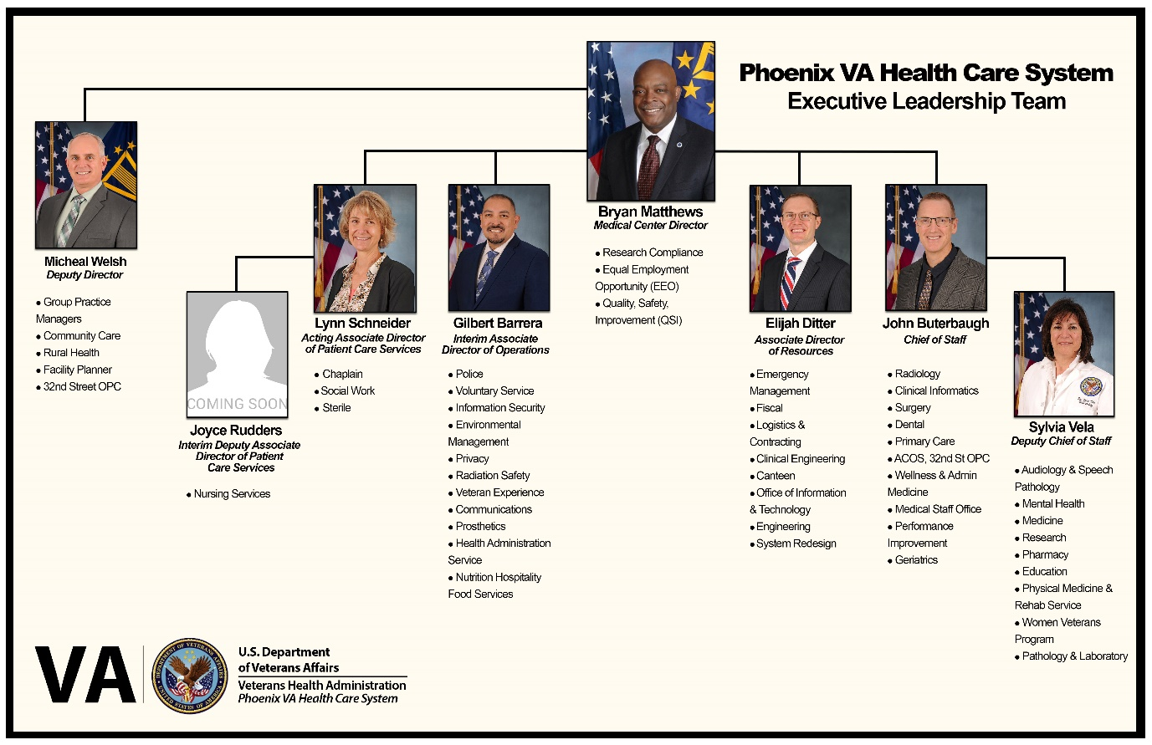
In addition to Mr. Matthew’s arrival there has been some leadership position changes. See below for an update of your Phoenix VA Health Care System executive leadership team. Our normal Associate Director of Patient Care Services and Nurse Executive, Dr. Leslie Lockridge, will be serving as the Acting Deputy Medical Center Director for the Southwest Louisiana VA Health Care System for the next 120 days.

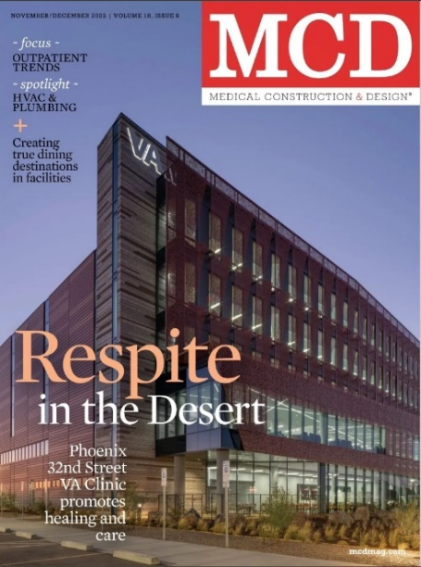
- A feasibility study site visit was conducted from November 29 – December 2 for the preparation of an Economic Business Case Analysis for the replacement of the PVAHCS, to be presented to VA leadership in October 2023. Interviews were completed with ELT, service line and support service leadership, and VSOs and various PVAHCS clinics were toured. Based on the findings from the visit a development delivery plan with be created and presented to ELT in mid-Jan.
- After receiving multiple awards, the Phoenix 32nd Street VA Clinic finished 2022 strong with a cover story in Medical Construction + Design Magazine.
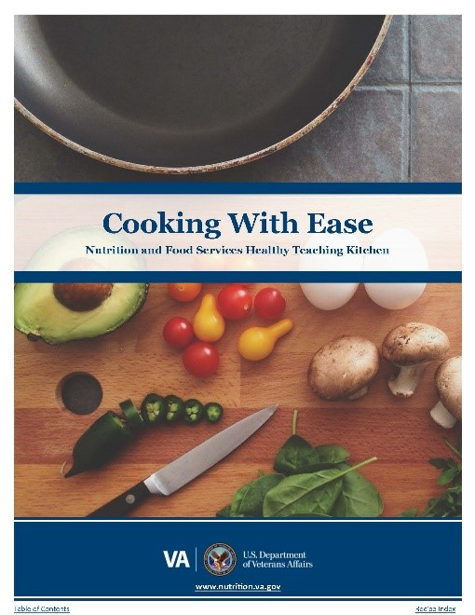
- The Phoenix VA Health Care System had three of its very own selected in a very competitive Health Care Leadership Development Program. HCLDP is comprehensive, leadership program for aspiring healthcare leaders preparing for a VHA executive position. The three-week residency program applies competencies for successful healthcare leadership and uses a variety of modalities and senior leader coaches to develop these key skills with ongoing feedback. Congratulations to Dr. Joelle Oizumi, Clinic Psychologist, Julie Kurtz, Chief of Nutrition, Hospitality Food Services, and Dr.xxxxxxxx
- Some of our amazing local Dietitians here at the Phoenix VA Health Care System completely revamped the “Cooking with Ease Cookbook”. This cookbook replaces the original Cooking with Ease Cookbook, with a collection of over 50 simple yet delicious recipes in various cooking method categories: no-cook, microwave, stovetop, oven, and slow cooker. The cookbook also includes a set of never-before-seen handouts which target various aspects of improving the cooking and meal preparation process.

- A new strategic plan for 2023 has been completed. You can view the complete version by click the image below.
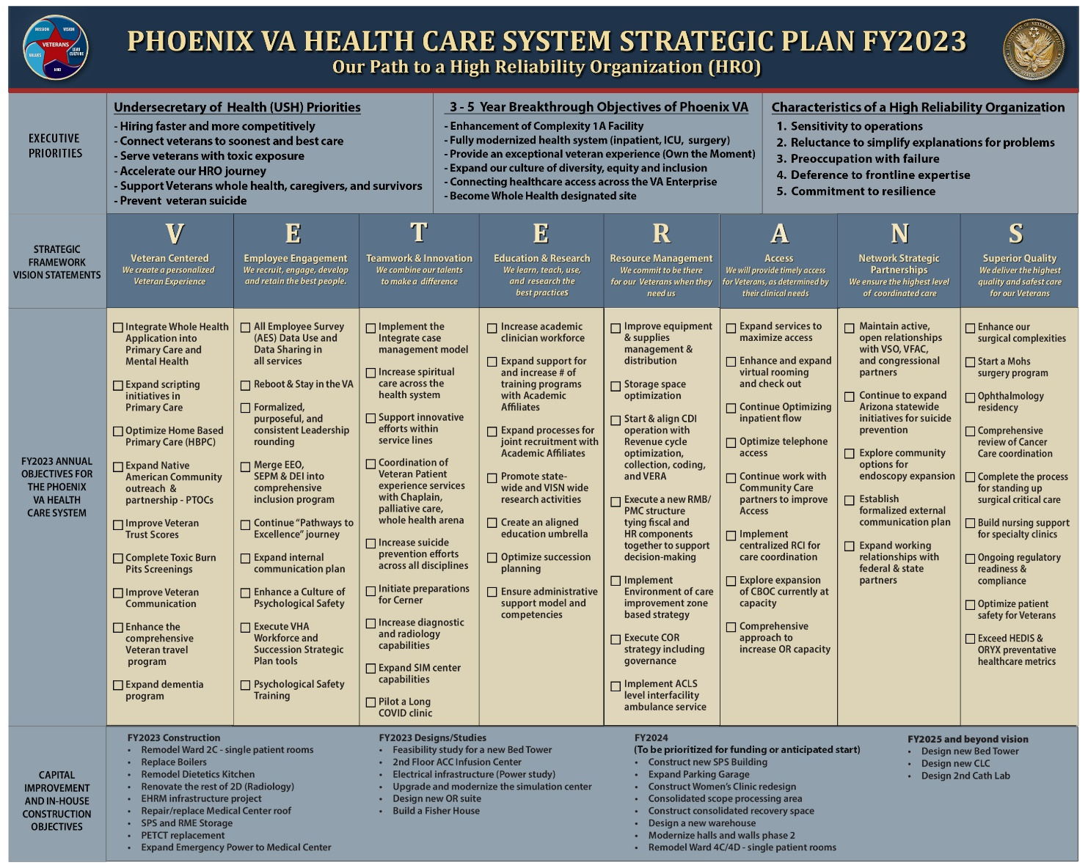

VETERAN REMINDERS
Masking Update:
- We continue to require FDA-approved Medical Procedure masks for all who enter our facilities. VA will issue a disposable mask when you arrive on campus if you do not have one. This applies to all patients, visitors, employees, contractors, and volunteers and applies to all buildings in which PVAHCS employees are working.

Visitor Policy:
- All visitors will be screened according to CDC guidelines and will be required to wear a mask.
- Our visitor policy has returned to pre-COVID hours.
- No visitors under age 15 on inpatient units.
- Visitors are now allowed in our Community Living Center in a limited capacity based on community positivity and transmission rates.

Vaccinations:
- Flu and COVID-19 vaccinations can keep you from getting sick this season and reduce the risk of being hospitalized. Getting a Flu and COVID-19 shot is especially important for people with health conditions such as diabetes and heart disease. Pregnant women and young children should also get a flu shot. Getting vaccinated yourself may also protect people around you, including those who are more vulnerable to serious flu and COVID illness. Go to any VA facility and get your COVID booster and Flu shot or visit one of our community partners.

- COVID-19 and flu vaccines are now available at our Phoenix 32nd Street VA Clinic. The COVID-19 Vaccination Clinic is located on the 1st floor in the specialty clinic. Hours are Monday - Friday 6:30 a.m. to 4 p.m.

Veteran Crisis Line:
This shorter, three-digit number provides an easier-to-remember way to access help for those who need it.

Access to Care Website:
VHA has launched an updated Access to Care website Accesstocare.va.gov. This improved site is a resource for Veterans and their caregivers, providing them with an improved user experience, additional access and satisfaction information, and improved wait times that better align with their experience when scheduling appointments.

LOOKING FORWARD
- Payson Coffee Talk Outreach Tuesday, January 31.
- Martin Luther King Celebration, January 12.

LOCAL CONTACT INFORMATION
• Phoenix VA Health Care System Main Line 602-277-5551
• Caregiver Support Program x7777
• Community Care x6049
• Eligibility and Enrollment Section x6508
• Homeless Program CRRC 602-248-6040
• Mental Health Clinic x2752
• Patient Advocate Office x2774
• Communications Department (Public Affairs/Medical Media) x2667
• Release of Information Office x3267
• Voluntary Services x7045
• Billing and Insurance x2173

VA NATIONAL CONTACT INFORMATION
• 1-800-MyVA411 (1-800-698-2411) questions about care, benefits, and services
• General VA Billing Questions 1-866-400-1238
• National Caregiver support line 1-855-260-3274
• National Memorial Cemetery Phoenix 1-480-513-1412
• Phoenix Regional Office (VBA) 1-800-827-1000
• VA Billing and collections Consolidated Patient Account Center (CPAC) 1-866-802-6819
• VA Desert Pacific Healthcare Network Nurse Advice Line 1-877-252-4866
• VA Health Care 1-877-222-8387 (VETS)
• Veterans Crisis Line 9 Press 1, text 838255, or chat VeteransCrisisLine.net/chat

